JOMO KENYATTA UNIVERSITY OF AGRICULTURE AND TECHNOLOGY
SCHOOL OF COMPUTING AND INFORMATION TECHNOLOGY
COURSE OUTLINE
MIT 3104 ADVANCED DATABASE SYSTEMS AND MANAGEMENT

LECTURER: DR. MWALILI TOBIAS M
Pre-requisites: None
Course Purpose
To provide in depth understanding of object oriented database development, implementation and management and the techniques and tools for developing and utilizing databases in business.
Learning Outcomes
By the end of the course units the learner should be able to;
- Explain the principle of object oriented databases
- Use structured query language (SQL) to access and manipulate data.
- Optimize databases using Advanced SQL
- Design and develop relational and object oriented databases
- Design and Implement distributed Databases
Course Content
Introduction Concepts: Relational model and algebra, SQL basics Database Tuning, Parallel database systems and high-performance sorting, Distributed query processing , Concurrency control. SQL in the real world: embedded SQL, data passing, status, cursor, connection, transaction, stored procedure; dynamic SQL, parameter, descriptor; JDBC; SQLJ; ODBC. Object Oriented databases: from relational to object-oriented: less redundancies, simpler queries, conceptual object data model: objects (void, value) & values (prim, ref, tupple, set), classes (type, method signatures, extent) & types (also 4 kinds), subtypes, database schema & instance. Query processing: external sort, duplicate removal, computing projections, computing selections, access path. Computing joins: block nested loops, index-nested loops, sort-merge, hash; star joins: using join index, bitmap indices; choosing indices. Query optimization: equivalence rules; heuristics: pushing selections and projections in, pipelining; cost estimation. Estimating output size; choosing query evaluation plan; incremental update for optimization, example of computing averages. Distributed databases: kinds of data distribution, views of developers; data fragmentation, replication, performance analysis. OLAP, data mining, and data warehouses: OLAP, vs OLTP, vs data mining; multidimensional model, star schema; aggregation, drilling, rolling, slicing, dicing; CUBE, ROLLUP.
COURSE OUTLINE
WEEK | TOPIC | ASSGMTS/  CATS
1 | Review of Database Concepts and The Relational Data Model
2 | SQL: Data Manipulation
3 | SQL: Data Definition
4 | Object-Relational DBMSs
5 | CAT 1
6 | Entity—Relationship Modeling
7 | Transaction Management
8 | Query Processing
9 | Distributed DBMSs and Replication
10 | CAT 2
12 | Object-Oriented DBMSs–Concepts and Design
13 | Data Warehousing Concepts and Design
14 | Online Analytical Processing and Data Mining
15 | Examination
16 | Examination

Teaching Methodologies
Lectures, Tutorials, Demonstrations, Presentations, Discussions.
Instructional Materials/Equipment
Whiteboard, Computers and Internet, appropriate software.
Course Assessment
40% Continuous Course Assessment (Tests 10%, Assignment 10%, Practical 20%)
60% End of Semester Examination.
Course Textbooks
- Michael Manino, Database Design, Application, Development, & Administration, Third Edition, McGraw-Hill, 2007, ISBN: 0072942207
- Benjamin Rosenzweig, Silvestrova E., Oracle PL/SQL by Example, Prentice Hall PTR Oracle Series, 2003,ISBN-10: 0131172611.
- Howe D. R., Data Analysis for Database Design, Butterworth Heinemann (3rd Ed), 2001, ISBN: 0750650869
- Watson, R.J., Data Management: Database & Organizations, Wiley (4th Ed), 2003, ISBN: 0471452254
Reference Textbooks
- Groff & Weinberg, SQL: The Complete Reference, McGraw Hill (Osbourne Media), 2nd Ed., 2002, ISBN: 0072225599
- McFadden J.A., & Hoffer F.R., Modern Database Management, Benjamin Cummins (7th Ed), 2004, ISBN: 0131453203
- Korth, Silberschatz, Sudarshan, Database System Concepts, McGraw Hill (5th Ed), 2001, ISBN: 007124476
Course Journals
- Acta Informatica ISSN 0001-5903
- Advances in Computational Mathematics ISSN 1019-7168
- Advances in data Analysis and Classification ISSN1 1862-5347
- Annals Of software Engineering ISSN 1022-7091

Reference Journals
- Journal of computer science and Technology ISSN 1000-9000
- Journal of Science and Technology ISSN 1860-4749
- Central European Journal Of Computer Science ISSN 1896-1533
- Cluster computing ISSN 1386-7857
Introduction to Databases
File-Based Systems
- Collection of application programs that perform services for the end users (e.g. reports).
- Each program defines and manages its own data.
Limitations of File-Based Approach
Separation and isolation of data
- Each program maintains its own set of data.
- Users of one program may be unaware of potentially useful data held by other programs.
Duplication of data
- Same data is held by different programs.
- Wasted space and potentially different values and/or different formats for the same item.
Data dependence
- File structure is defined in the program code.
Incompatible file formats
- Programs are written in different languages, and so cannot easily access each other’s files.
Fixed Queries/Proliferation of application programs
- Programs are written to satisfy particular functions.
- Any new requirement needs a new program.
Database Approach
Arose because:
- Definition of data was embedded in application programs, rather than being stored separately and independently.
- No control over access and manipulation of data beyond that imposed by application programs.
Result:
- the database and Database Management System (DBMS).
Database
- Shared collection of logically related data (and a description of this data), designed to meet the information needs of an organization.
- System catalogue (metadata) provides description of data to enable program–data independence.
- Logically related data comprises entities, attributes, and relationships of an organization’s information.
Database Management System (DBMS)
- A software system that enables users to define, create, maintain, and control access to the database.
- (Database) application program: a computer program that interacts with database by issuing an appropriate request (SQL statement) to the DBMS.
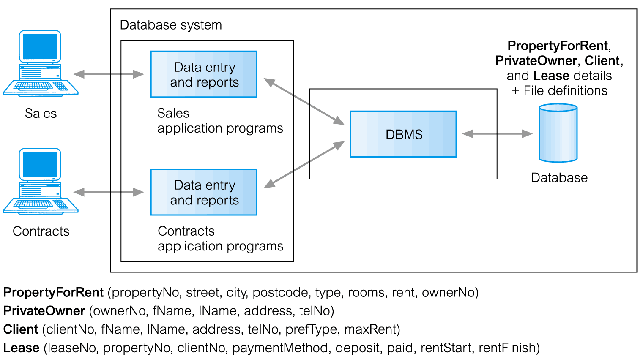

Data definition language (DDL).
- Permits specification of data types, structures and any data constraints.
- All specifications are stored in the database.
Data manipulation language (DML).
- General enquiry facility (query language) of the data.
Controlled access to database may include:
- a security system
- an integrity system
- a concurrency control system
- a recovery control system
- a user-accessible catalog.

Views
- Allows each user to have his or her own view of the database.
- A view is essentially some subset of the database.
Views – Benefits
- Reduce complexity
- Provide a level of security
- Provide a mechanism to customize the appearance of the database
- Present a consistent, unchanging picture of the structure of the database, even if the underlying database is changed
Components of DBMS Environment
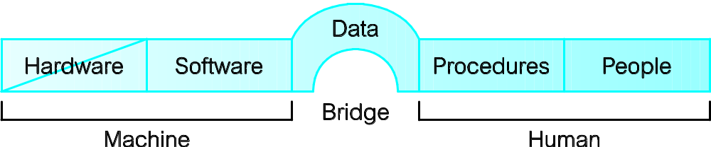
Hardware
- Can range from a PC to a network of computers.
Software
- DBMS, operating system, network software (if necessary) and also the application programs.
Data
- Used by the organization and a description of this data called the schema.
Procedures
- Instructions and rules that should be applied to the design and use of the database and DBMS.
People

Roles in the Database Environment
- Data Administrator (DA)
- Database Administrator (DBA)
- Database Designers (Logical and Physical)
- Application Programmers
- End Users (naive and sophisticated)
History of Database Systems
First-generation
- Hierarchical and Network
Second generation
- Relational
Third generation
- Object-Relational
- Object-Oriented
Advantages of DBMSs

- Control of data redundancy
- Data consistency
- More information from the same amount of data
- Sharing of data
- Improved data integrity
- Improved security
- Enforcement of standards
- Economy of scale
- Balance conflicting requirements
- Improved data accessibility and responsiveness
- Increased productivity
- Improved maintenance through data independence
- Increased concurrency
- Improved backup and recovery services

Disadvantages of DBMSs
- Complexity
- Size
- Cost of DBMS
- Additional hardware costs
- Cost of conversion
- Performance
- Higher impact of a failure

Database Environment
Chapter 2 – Objectives
- Purpose of three-level database architecture.
- Contents of external, conceptual, and internal levels.
- Purpose of external/conceptual and conceptual/internal mappings.
- Meaning of logical and physical data independence.
- Distinction between DDL and DML.
- A classification of data models.
- Purpose/importance of conceptual modelling.
- Typical functions and services a DBMS should provide.
- Function and importance of system catalog.
- Software components of a DBMS.
- Meaning of client–server architecture and advantages of this type of architecture for a DBMS.
- Function and uses of Transaction Processing Monitors.
Objectives of Three-Level Architecture
- All users should be able to access same data.
- A user’s view is immune to changes made in other views.
- Users should not need to know physical database storage details.
- DBA should be able to change database storage structures without affecting the users’ views.
- Internal structure of database should be unaffected by changes to physical aspects of storage.
- DBA should be able to change conceptual structure of database without affecting all users.
ANSI-SPARC Three-Level Architecture

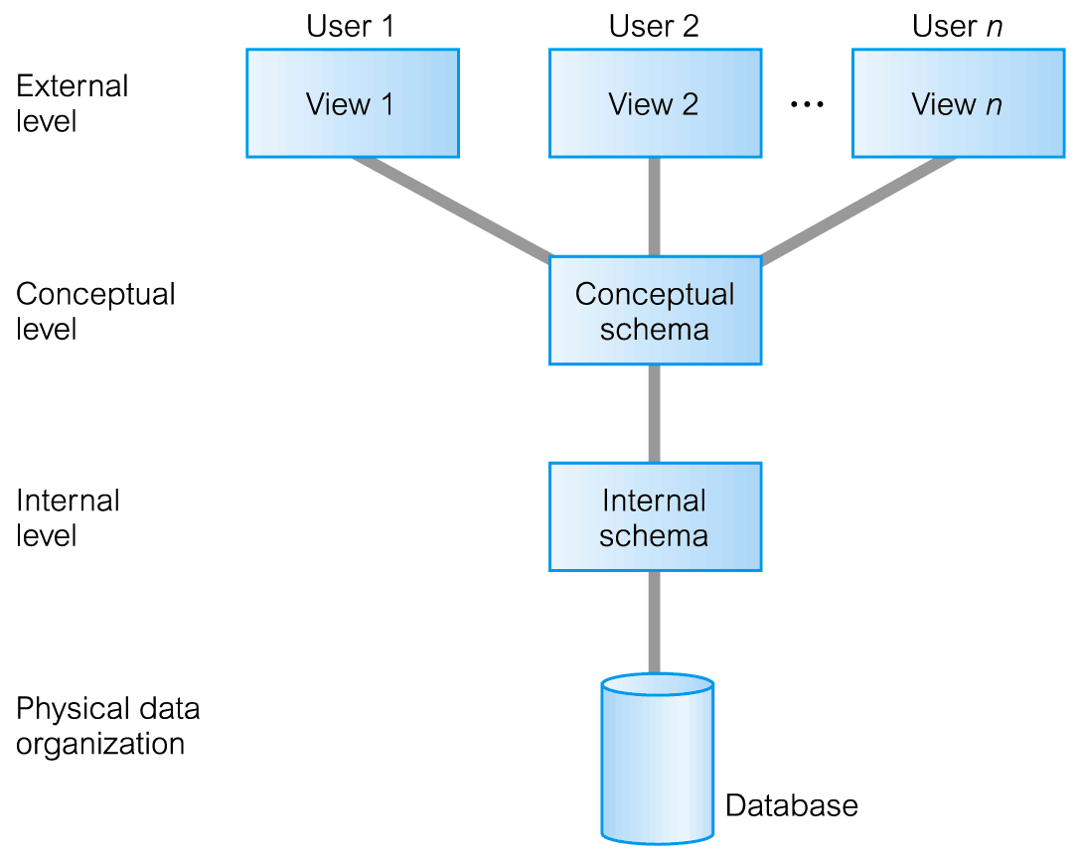
ANSI-SPARC Three-Level Architecture
External Level
- Users’ view of the database.
- Describes that part of database that is relevant to a particular user.
Conceptual Level
- Community view of the database.
- Describes what data is stored in database and relationships among the data.
Internal Level
- Physical representation of the database on the computer.
- Describes how the data is stored in the database.
Differences between Three Levels of ANSI-SPARC Architecture
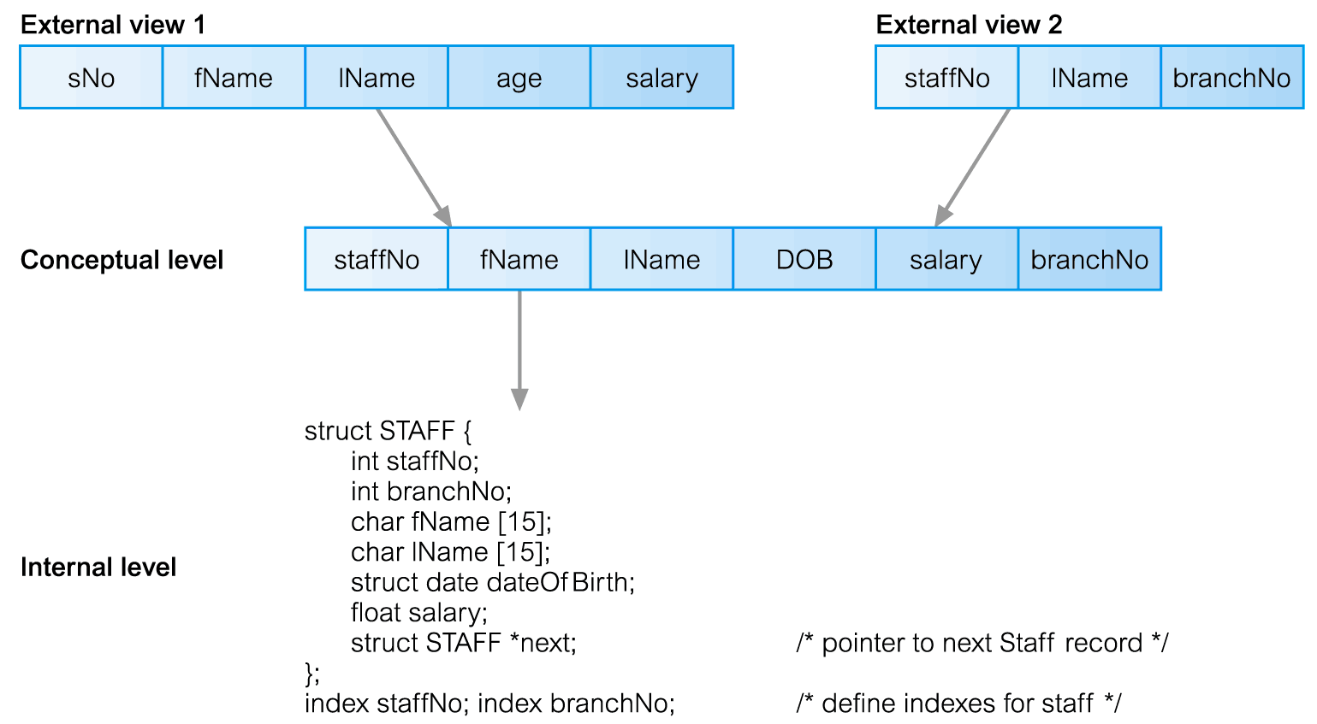
Data Independence
Logical Data Independence
- Refers to immunity of external schemas to changes in conceptual schema.
- Conceptual schema changes (e.g. addition/removal of entities).
- Should not require changes to external schema or rewrites of application programs.
Physical Data Independence
- Refers to immunity of conceptual schema to changes in the internal schema.
- Internal schema changes (e.g. using different file organizations, storage structures/devices).
- Should not require change to conceptual or external schemas.
Data Independence and the ANSI-SPARC Three-Level Architecture
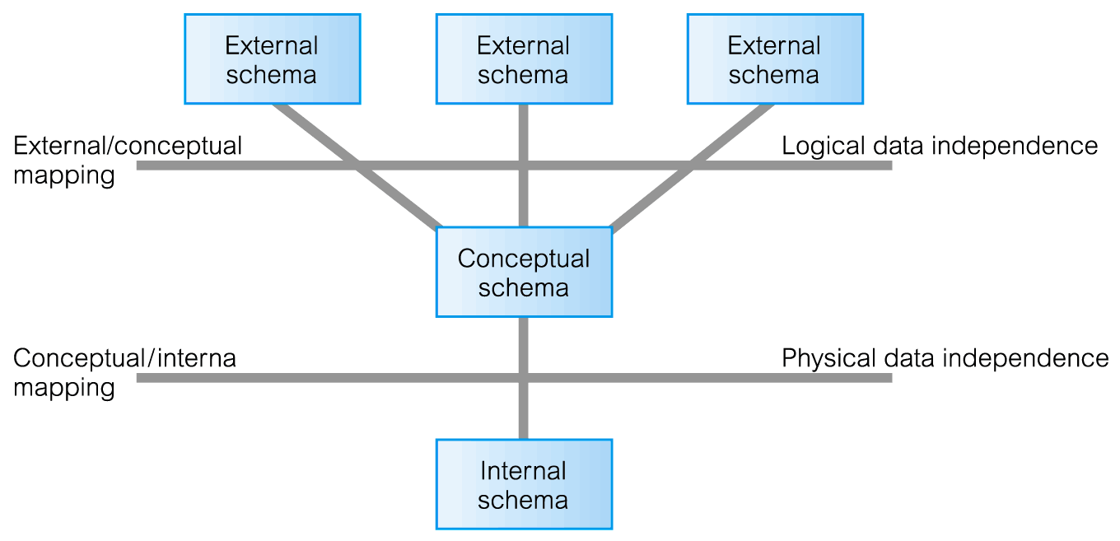
Database Languages
Data Definition Language (DDL)
- Allows the DBA or user to describe and name entities, attributes, and relationships required for the application plus any associated integrity and security constraints.
Data Manipulation Language (DML)
- Provides basic data manipulation operations on data held in the database.
Procedural DML
- Allows user to tell system exactly how to manipulate data.
Non-Procedural DML
- Allows user to state what data is needed rather than how it is to be retrieved.
Fourth Generation Languages (4GLs)
Data Model
Integrated collection of concepts for describing data, relationships between data, and constraints on the data in an organization.
Data Model comprises:
- a structural part;
- a manipulative part;
- Possibly a set of integrity rules.
Purpose
To represent data in an understandable way.
Categories of data models include:
- Object-based
- Record-based
- Physical.
Object-Based Data Models
- Entity-Relationship
- Semantic
- Functional
- Object-Oriented.
Record-Based Data Models
- Relational Data Model
- Network Data Model
- Hierarchical Data Model.
Physical Data Models

Relational Data Model
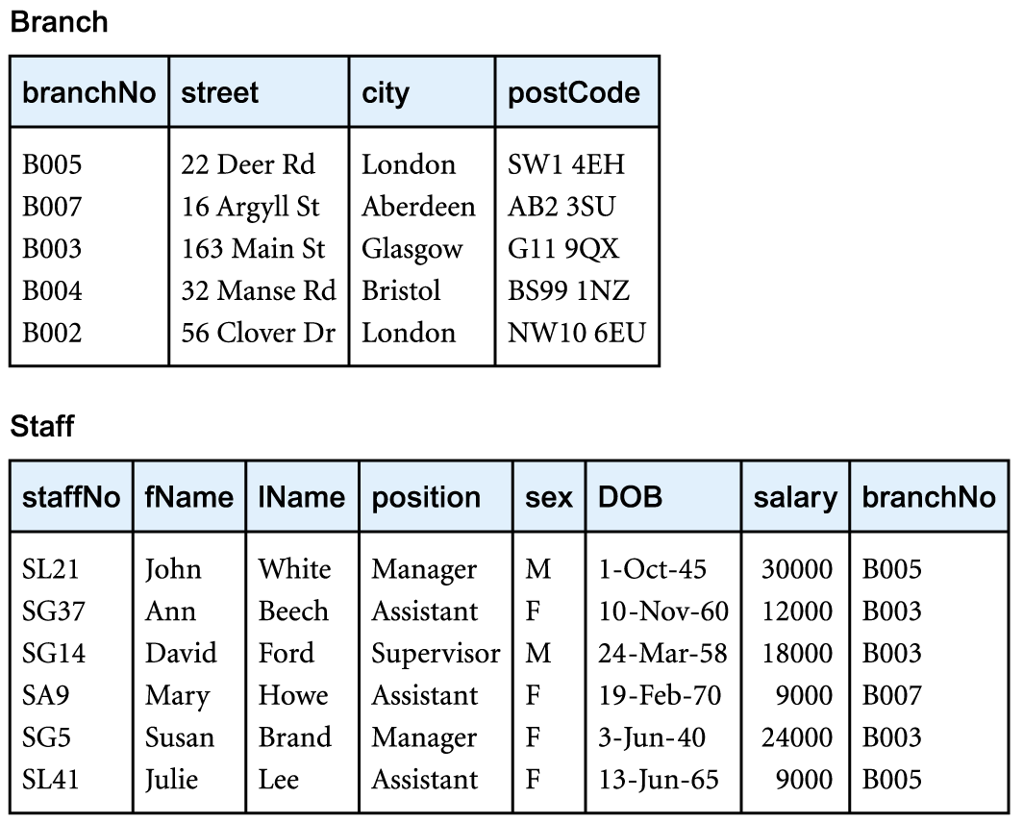
Network Data Model
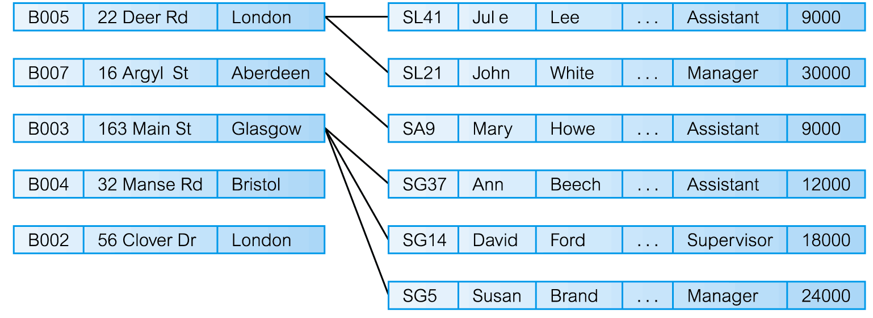
Hierarchical Data Model
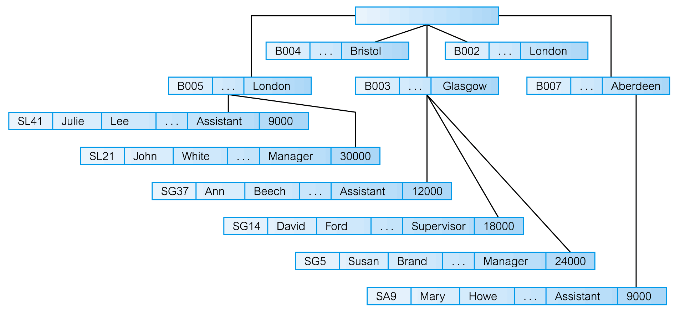
Conceptual Modelling
- Conceptual schema is the core of a system supporting all user views.
- Should be complete and accurate representation of an organization’s data requirements.
- Conceptual modelling is process of developing a model of information use that is independent of implementation details.
- Result is a conceptual data model.
Functions of a DBMS
- Data Storage, Retrieval, and Update.
- A User-Accessible Catalog.
- Transaction Support.
- Concurrency Control Services.
- Recovery Services.
- Authorization Services.
- Support for Data Communication.
- Integrity Services.
- Services to Promote Data Independence.
- Utility Services.
System Catalog
- Repository of information (metadata) describing the data in the database.
- One of the fundamental components of DBMS.
- Typically stores:
- names, types, and sizes of data items;
  - constraints on the data;
  - names of authorized users;
  - data items accessible by a user and the type of access;
  - usage statistics.
Components of a DBMS
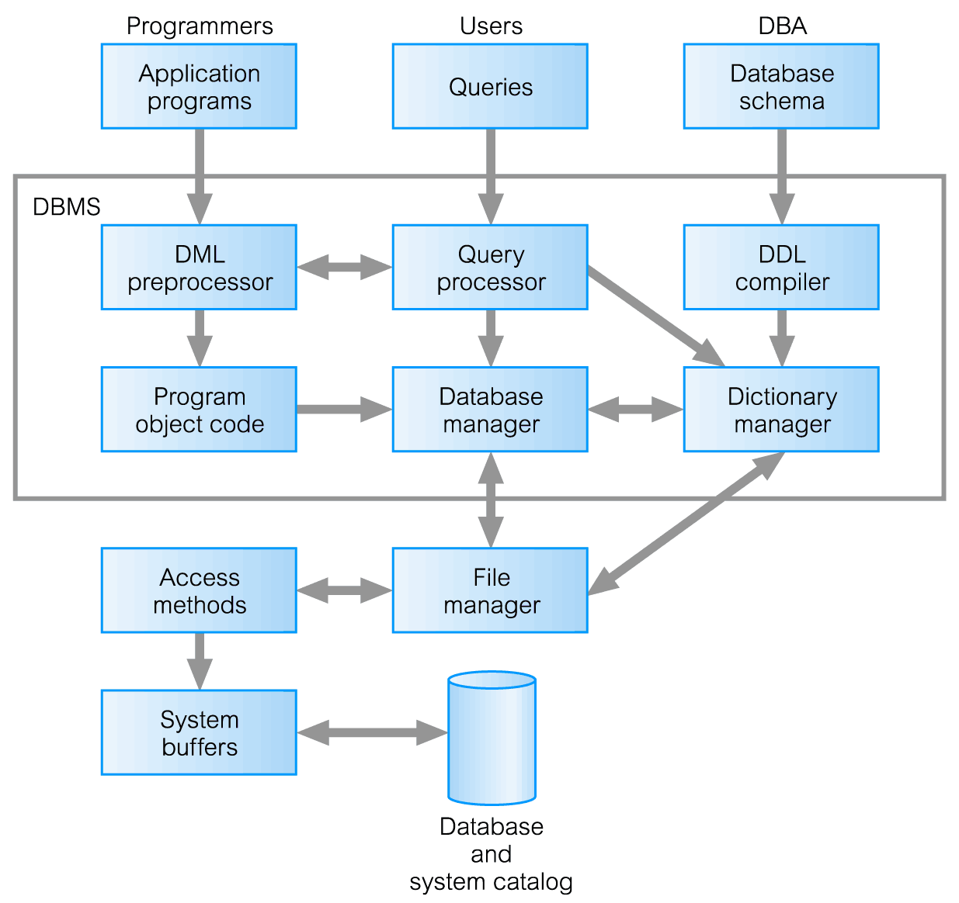
Components of Database Manager
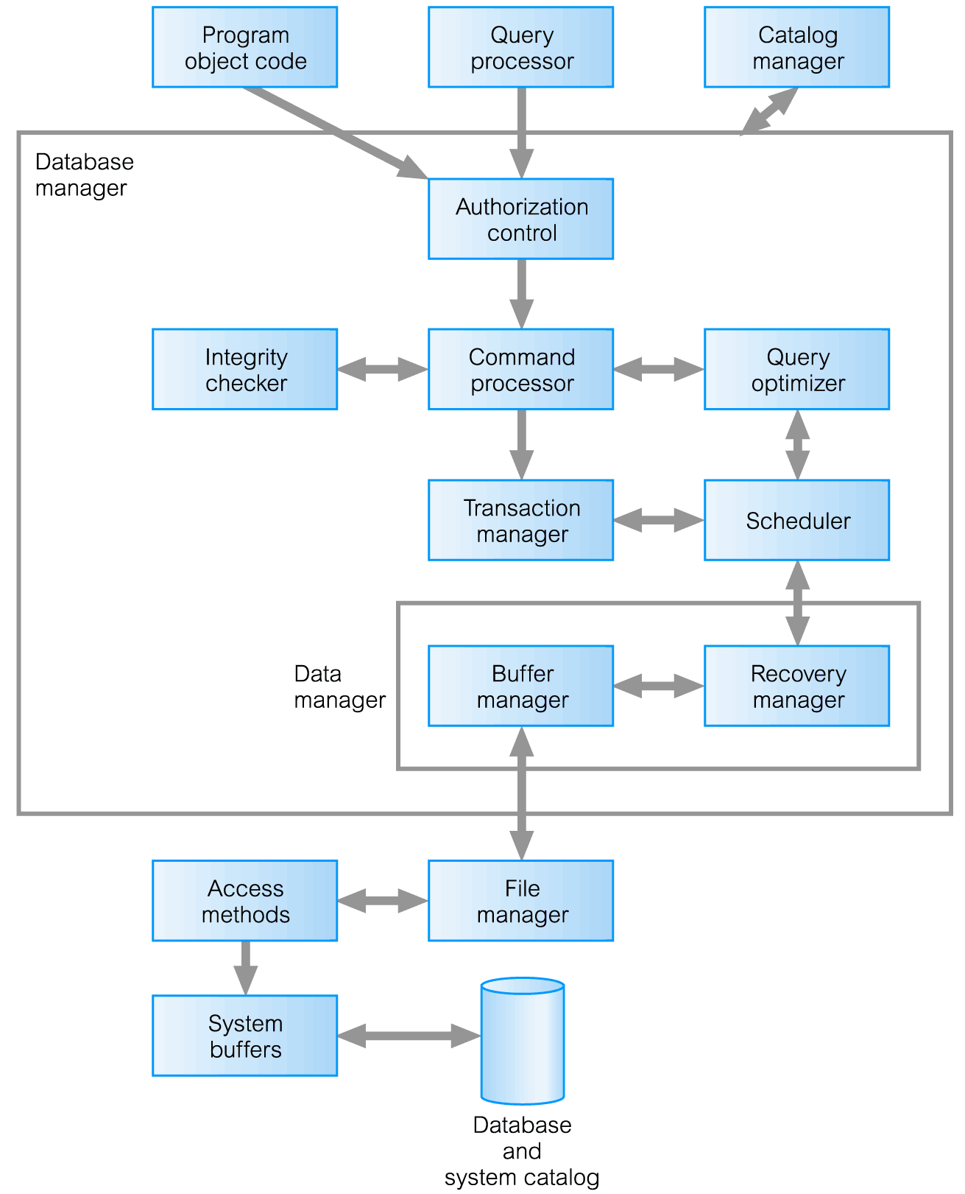
Multi-User DBMS Architectures
- Teleprocessing
- File-server
- Client-server
Teleprocessing
- Traditional architecture.
- Single mainframe with a number of terminals attached.
- Trend is now towards downsizing.
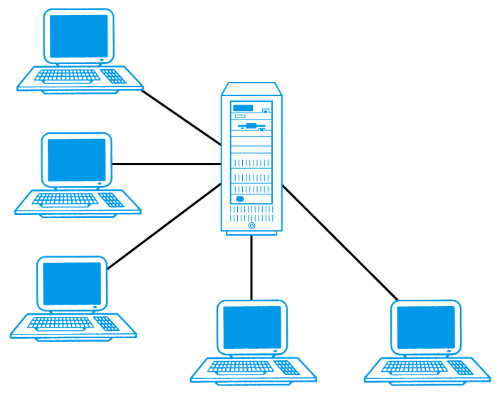
File-Server
- File-server is connected to several workstations across a network.
- Database resides on file-server.
- DBMS and applications run on each workstation.
Disadvantages include:
- Significant network traffic.
- Copy of DBMS on each workstation.
- Concurrency, recovery and integrity control more complex.
File-Server Architecture
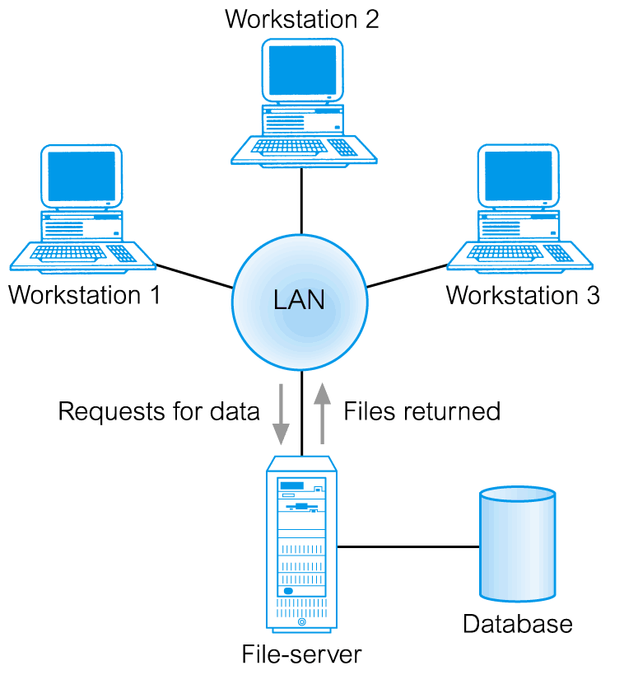
Traditional Two-Tier Client-Server
- Client (tier 1) manages user interface and runs applications.
- Server (tier 2) holds database and DBMS.
Advantages include:
- wider access to existing databases;
- increased performance;
- possible reduction in hardware costs;
- reduction in communication costs;
- Increased consistency.
Traditional Two-Tier Client-Server
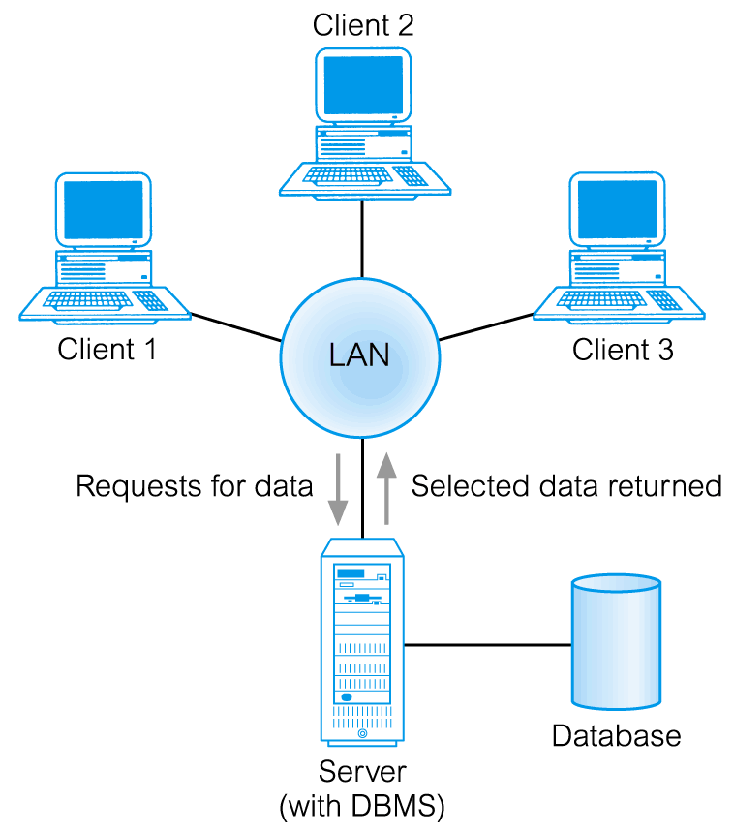
Traditional Two-Tier Client-Server
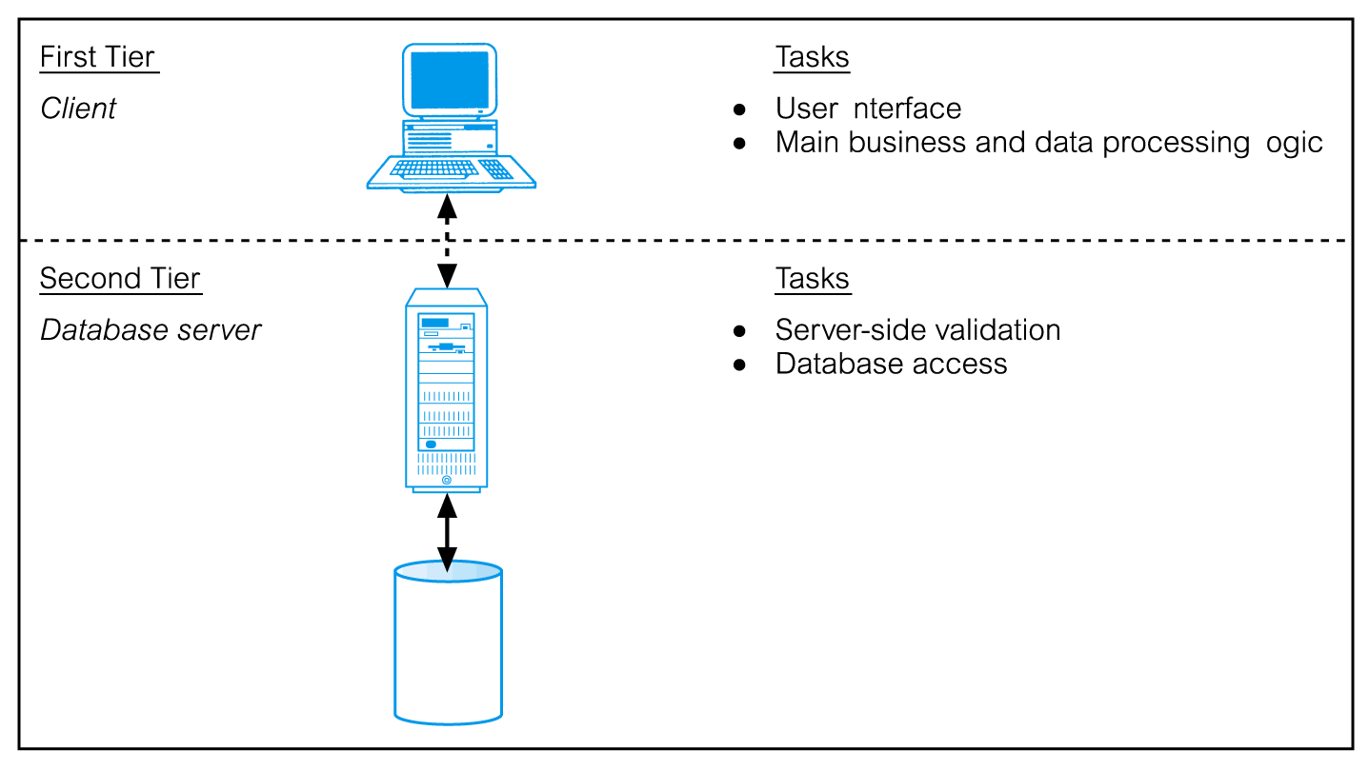
Three-Tier Client-Server
Client side presented two problems preventing true scalability:
- ‘Fat’ client, requiring considerable resources on client’s computer to run effectively.
- Significant client side administration overhead.
By 1995, three layers proposed, each potentially running on a different platform.
Advantages:
- ‘Thin’ client, requiring less expensive hardware.
- Application maintenance centralized.
- Easier to modify or replace one tier without affecting others.
- Separating business logic from database functions makes it easier to implement load balancing.
- Maps quite naturally to Web environment.
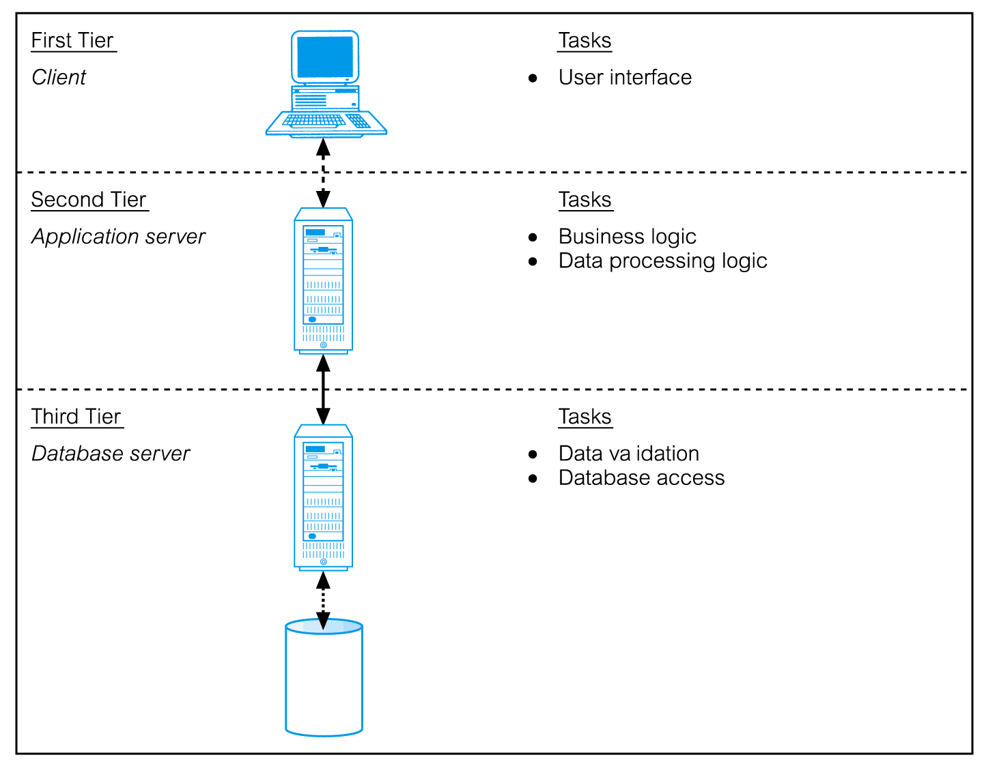
Transaction Processing Monitors
Program that controls data transfer between clients and servers in order to provide a consistent environment, particularly for Online Transaction Processing (OLTP).
TPM as middle tier of 3-tier client-server
